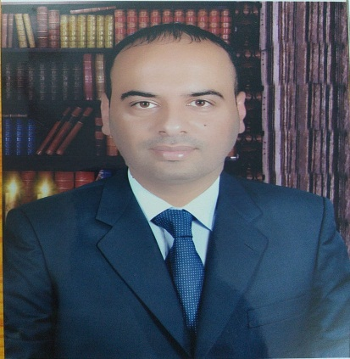
الاسم:- محمد رسول مهدي جاسم الكلابي
التولد:- 1/1/1988
الحالة الاجتماعية:- متزوج
الكلية:- الزراعة
الشهادة:- الدكتوراه
التخصص:- انتاج حيواني / دواجن/ فسلجة طيور داجنة
اللقب العلمي وتاريخ الحصول عليه:- مدرس 2020
محل العمل:- جامعة القادسية- كلية الزراعة- قسم الانتاج الحيواني.
الايميل:- moh.rasool@qu.edu.iq
المؤهلات العلمية (الشهادات)
ت | الشهادة | الكلية المانحة للشهادة | الجامعة المانحة للشهادة | تاريخ الحصول على الشهادة
1 | البكلوريوس | كلية الزراعة | جامعة المثنى | 2008/2009
2 | الماجستير | الكلية التقنية- المسيب | جامعة الفرات الاوسط التقنية | 2012
3 | الدكتوراه | كلية علوم الهندسة الزراعية | جامعة بغداد | 2020

Full Name:- MOHAMMED RASOUL MAHDI JASIM AL-KELLABE.
Date of Birth: 1-1-1988
Marital Status: married
College: Agriculture
Certificate:- PhD.
Specialization:- Animal Production (POULTRY PHYSIOLOGY).
Academic titles: Lecturer 2020
Work address:-Department of Animal Production,Faculty of Agriculture,University of Al-Qadisiyah.
E.Mail:- - moh.rasool@qu.edu.iq.
Academic Qualifications (Cetificates)
NO. | Academic  qualification | College | University | Date  obtained
1 | B. Sc | Agriculture science | AL-MUTHANNA UNIVERSITY | 2008/2009
2 | M. Sc | Technical College/Al-Mussaib | Al-Furat Al-Awsat Technical | 2012
3 | Ph.D | Agricultural Engineering  Sciences | Baghdad University | 2020
Scientific researches
NO. | Research Title
1 | Effect of Supplementing Alcoholic and Aqueous Extract of Khalal and Seedless Date and Date  Seed Khalal AL-Zahdi Date (Phoenix Dactylifera L.) to Drinking Water on Some Physiological  and Microbial Traits of Broiler Reared Under High Temperature
2 | Effect of Addition Stachys Lamiaceae Water Extract on Chilling Sheep Sperms Derived from the  Vas Deference’s
3 | Efficiency of Cordia MYXA (Bumber) Fruit Powder added to Broiler Diets Exposed to Heat Stress  on Productive and Physiological Performance
4 | Effect of Supplementing Alcoholic and Aqueous Extract ofSeedless Date and Date Seed of  Khalal AL-Zahdi Date (Phoenixdactylifera L.) to Drinking Water on Productive Traits of Broiler  Chickens Reared under High Temperature
5 | Effect of Supplementing Alcoholic and Aqueous Extract of Khalal and Seedless Date and Date Seed Khalal AL-Zahdi Date (Phoenix dactylifera ) L. to Drinking Water on Some Productive Traits of Quail Females reared Under High Temperature
6 | Efficiency of the Effect of Adding Anise and Marjoram Powders and their Mixture to the Feeds  of Local Male Roosters on Semen Characteristics
7 | Effect of Supplementing Alcoholic and Aqueous Extract of Khalal and Seedless Date and Date  Seed Khalal AL-Zahdi Date (Phoenix dactylifera L.) to Drinking Water on Some Physiological  and Microbial Traits of Females of Quail Reared under High Temperature
8 | Effect of Adding Anise and Marjoram Seed Powders and Their Mixtures to Iraqi Local  Chicken Male Diets on Seminal Plasma Traits

