C.V
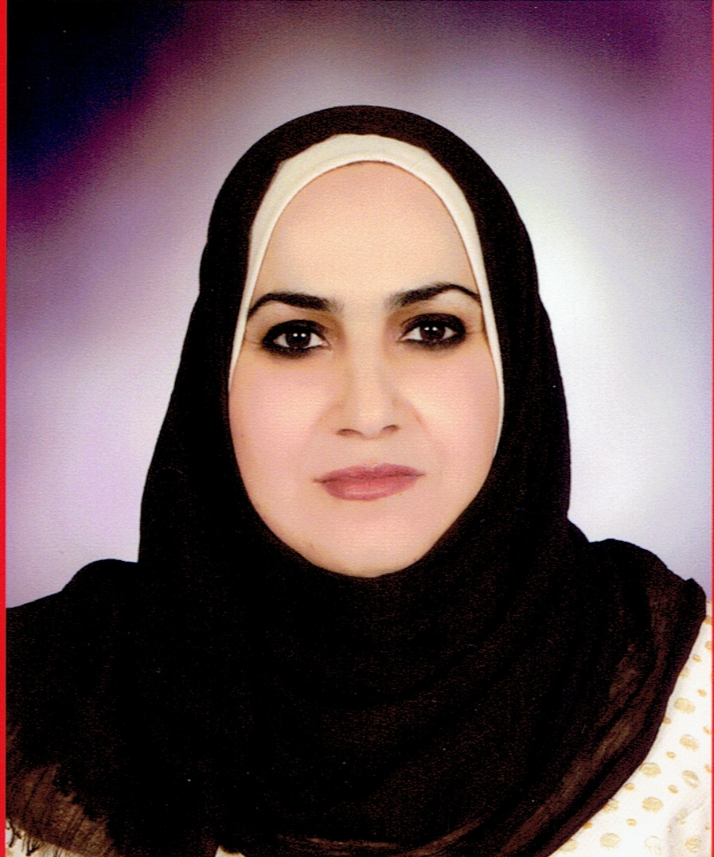

Photo

Name: Huda Enaya Mahood
Date of Birth: 1977
Religion: Muslim
Martial statues: Married
Specialization: Plant Tissue Culture
Position: Teacher
Scientific Degree: Lecturer
Work Address: University of AL- Qadisiyah - College of Agriculture
E-mail: huda.enaya@qu.edu.iq

Scientific Certification:

Date | College | University | Degree science
2001 | Education | AL- Qadisiyah | B.Sc.
2014 | Sciences for women | Baghdad | M.Sc.
2018 | Sciences for women | Baghdad | Ph.D.
 |  |  | Any other
Date | Scientific Title | No.
5/1/2015 | Assistant Lecturer
12/11/2018 | Lecturer
Scientific Title

Courses Which You Teach:

Year | Subject | Department | No.
2019 | Biotechnology | College of Agriculture
2019 | Food industry | College of Agriculture

Thesis which was supervised by :

Year | Department | Thesis Title | No.

Conferences which you participated:
Type of Participation | Place | Year | Conferences Title | No.  ( بحث / بوستر حضور)
Presence | al-qadisiyah | 2019 | Conference | 1
Presence | al-qadisiyah | 2019 | Conference | 2
Presence | al-qadisiyah | 2019 | Work shop | 3
 |  |  |  | 4
 |  |  |  | 5
 |  |  |  | 6
 |  |  |  | 7

Scientific Activities:
Outside the College | Within the College

Awards and Certificates of Appreciation:

Year | Donor | Name of Awards and Certificates | No.
2019 | Dean of the college of Science s | Acknowledgments | 1
2018 | Dean of the college of Science s | Acknowledgments | 2
2018 | University of al-qadisiya | Acknowledgments | 9
2013 | University of AL-Qadisiyah | Acknowledgments | 10
2004 | Dean of the College of Veterinary Medicine | Acknowledgments | 11

Publication
Year | Publication | No.
2018 | IMPROVEMENT OF ALKALOIDS YIELD USING PHENYLALANINE AS A  PRECURSOR SUPPLEMENTED TO MORINA OLEIFERA L. CALLUS  CULTURES | 1
2018 | Evaluation the Effect of Growth Regulators and Explants Source  on Micro Propagation of Moringa Oleifera In Vitro | 2
2016 | Induction of Genetic Variation for Salt Tolerance in Tissue Culture of Capsicum annuumL. | 3
 |  | 4
 |  | 5
Books Composed or Translated :
Year | Donor | Name of Awards and Certificates | No.
 |  |  | 1
 |  |  | 2
 |  |  | 3
 |  |  | 4
 |  |  | 5
 |  |  | 6

languages:
- Arabic
- English

